Helping to discover yourself through Cooking

The Gap Christian Family Centre
  - Agency Pack

TABLE OF CONTENTS
Welcome 3
1. Project Background 4
2. Project Overview 5
3. Business Description 6
4. Market Analysis 8
5. Operating Plan 10

Welcome
Welcome to the GAP Christian Family Centre.
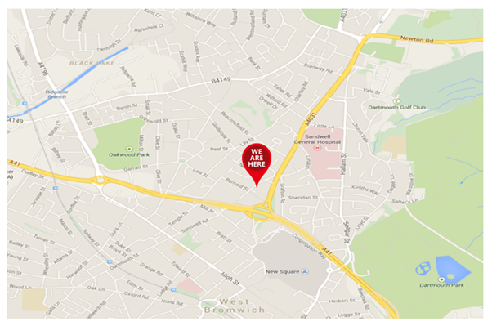
Our Centre is situated just outside the town centre of West Bromwich, a town which is full of learning opportunities with Sandwell College, the new Shireland CBSO Academy and Shireland Biomedical UTC.

We are privileged to be part of a town where learning is part of its embedded culture.

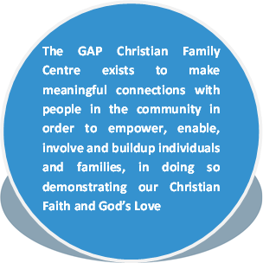
The Gap Christian Family Centre, established at the turn of this century, has been supporting our local communities, in particular, children and young people with its very clear mission:

Project Background
Education is embedded in the culture and make-up of the town of West Bromwich, where our charity has been based for over 22 years.
But ….
It is the lived experience of the founder and current CEO of the charity, that academia is not the natural pathway for everyone, there may be many reasons for this; the lack ability to comprehend and learn, the environment in which the learning takes places, external circumstances such as homelife, trauma, lack of confidence etc. I’m sure even before we start to unfold our project, there are students that have already come to your mind.

We are passionate about and driven to supporting and giving opportunities to those that may fit into this category and we have been working over several years now to create a project that does this.
At the beginning of 2021, we were fortunate to secure a small amount of development funding from National Lottery to develop some projects and activities to help the charity support our local community. As part of this funding, we were able to recruit and employ a cook who is equally as passionate and driven to support those who for whatever reason, find formal education difficult. So, we started to develop the concept that had been lying with the charity for several years and have come up within this project of combining learning in a practical way, in a non-educational environment with mentoring and developing young people in very informal way.
Our passion comes from our lived experiences!
Helping to discover yourself through cooking….
Our project was established…. a twelve-week program for individuals to develop basic cookery skills, and whilst doing their practical learning. Our very informal approach of building a non-judgmental, trust-based supportive relationship with the individual will create the safe environment to allow conversations to open, to enable the young person to discover more about themselves, using guided questioning and coaching skills.

Project Overview
The project is tailored to the individual young person, but will follow the same guided path, accumulating in the young person showcasing what they have learnt, and discovered about themselves in a small community cafe, where the young person will be able to invite their network of significant people to feast on their cookery skills, celebrate with them their successes and commit to support them in their next steps.
Each session is 2hrs and will have several elements in them.
- Time to settle in and chat about the previous week, giving young people time to unwind and share their experience is vital in valuing the young person, and building that non-judgmental supportive relationship.
- Understanding and demonstrating safe practice within the kitchen. We acknowledge that not all young people will be able to sit a Food Safety course, some of us adults struggle with them if we were honest, so we have taken the principles of Food Hygiene and will introduce them of the 12-week course, giving the young person repeated opportunities to demonstrate that they understand the principles of basic food hygiene.
- Discovering something about yourself. These will be conversations over a drink and maybe lunch that the young person has bought, or something they may have prepared throughout the session. During these times our staff will use guided questioning and coaching skills to support the young person where needed, but over the 12 weeks we will explore.
    - The current situation the young person is in, exploring together the objectives put on their referral forms, looking at barriers the young person might be facing and what they want to get out of their time on the project. We will use tools such as the wheel of life (Star Outcomes) and guided questioning to tease out and monitor this information.
    - Where would the young like to be? What are their aspirations? What are barriers to achieving these? Who is there to support them?
    - Different emotions and how they impact users, and how we might respond differently to get different responses from those around us.
    - Whatever crops up in general conversation.
- Practical cooking skills. We recognize that we are not teachers, nor are we claiming to be Gordon Ramsey…. And to be either would be to total miss the point of the whole project. The outcome is not the end goal; the discovery and learning during the process of the journey during the project is what we are celebrating. But over the course of the project each young person will be exposed to elements of cooking within the kitchen:
    - Measuring and weights (for the teachers reading this that is practical math’s.)
    - Knife skills and peeling (that’s hand - eye coordination, that’s confidence building, might even be problem solving.)
    - Following instructions, both written and verbal (that’s practical English, comprehension etc.)
Each session will build on existing skills and introduce a new skill set building towards the final session where the young person will be encouraged to showcase all they have discovered about themselves and cooking in front of their chosen friends and family, and maybe even a invite for staff member or two.

- Time to close and wind down. Each session will include time for the young person to understand the importance of closing the kitchen in an orderly fashion, and time for them to reflect on the session and their journey as a whole.
The Project will incorporate time to review progress and set objectives which remain tailored to the young person.

These are our structured programs; we also offer tailored sessions to suit your student’s needs, we recognize that students are unique individuals, and we will aim to work with you as the school or referring agent and the students to design a tailored program that meets their needs and objectives. This could range from a place to come and chill and build positive relationships, shorter interventions, sessions to develop cookery skills needed to support home life, or a pick and mix approach. We will remain flexible.

Commitment
Our Commitment
- Our Mission is to empower, enable, involve, and build up individuals. We are committed to ensuring that as far as we can, we provide a supportive and caring environment for the Young Person.
- On the rare occasion that we are unable to provide the project we will inform the referring agency at the very earliest opportunity so alternative arrangements can be made for the young person.
- We will inform the referring agency at the earliest possible time of any concerns or wellbeing issues as appropriate.
- We will maintain regular communication with the referring agency to share updates and progress, as well as to confirm safe arrival and departure of students, if requested.
The Young Person’s commitment
- To turn up to each session, engage and have a go.
- To inform the referring agency and us if they are unable to attend.
- To follow instructions given.
Agency Commitment
- To complete a referral form and share any relevant information to ensure the safe working of Gap Staff.
- To provide support and encouragement to the Young Person to complete the whole project.
- To supply The GAP Centre with Invoice information and to ensure invoices are paid within 7days. Our fees are £50 per session for 1 pupil or £75per session for 2 pupils. Invoice will be raised at the end of each month , or 2 weeks prior to School holidays whichever is more appropriate.

