Interested….  If you are in school, college, or in training ask your teacher to complete a referral form and return it Kirsty…… There is a small cost for each session for the school/college/training provider to pay…. but we are sure they we be able to sort this for you….  Each session is 2 hours long and we want you to get the most out of each session. The whole program is tailored to you. |  |  |  | 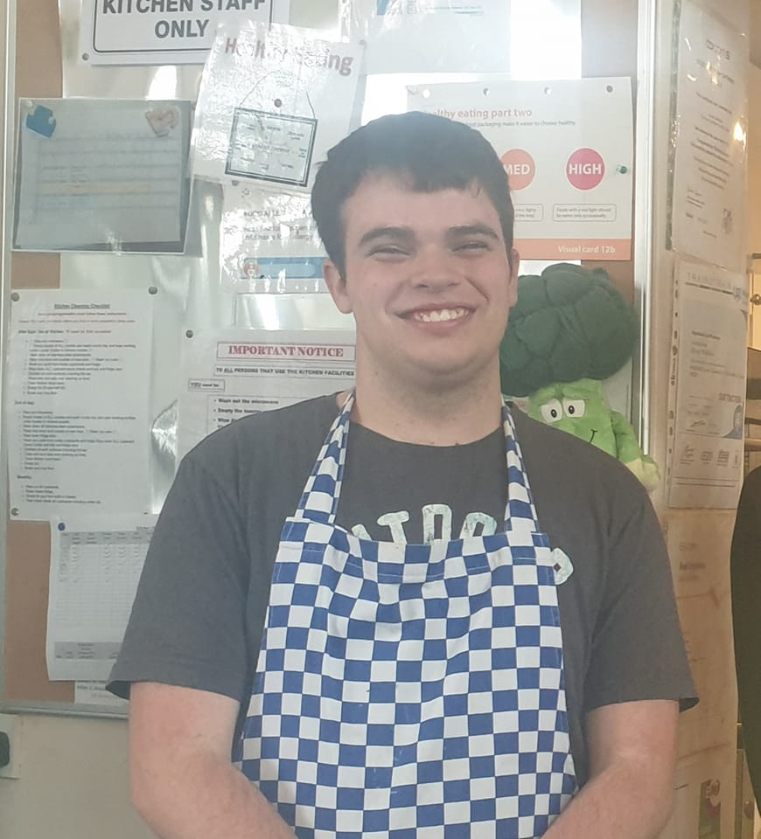
The GAP Christian Family Centre
Hargate Lane
West Bromwich
B71 1PH
Kirsty@thegaponline.org
0121 525 4442

www.thegaponline.org

 |  |  |  | Helping you discover yourself through cooking
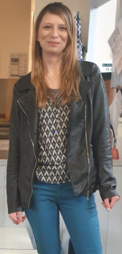  Helping you discover yourself through cooking.  Hello and welcome to Time2buildup- helping you discover yourself through cooking.  I’m Kirsty and I’m the new Time2buildup Coordinator at the Gap Centre. I’m passionate about all things food and love sharing my skills with others.  My other passion is helping people to overcome their barriers to get the best of life. I know what it is like to face difficulties, as a young person and as an adult too.  So, what better idea to combine both my passions to provide this project as part of the Gap mission to “make meaningful connections with people in the community to empower, enable, involve and build up individuals “ | What to expect!!!!!
Each session is 2hrs and will have several elements in them.
- Time to settle in and chat about the previous week, giving you time to unwind and share your experience.
- Understanding and demonstrating safe practice within the kitchen giving you repeated opportunities to demonstrate that you understand about basic food hygiene.
- Discovering something about yourself. These will be conversations over a drink and maybe lunch, or something you may have prepared throughout the session. Exploring together:
    - Your current situation, looking at barriers that you might be facing and what you want to get out of your time on the project.
    - Where would you like to be? What are your aspirations? What are barriers to achieving these? Who is there to support you?
    - Different emotions and how you feel, and how we might respond differently to get different responses from those around us.
    - Whatever crops up in general conversation.
- Practical cooking skills. We recognize that we are not teachers, nor are we claiming to be Gordon Ramsey…. And to be either would be to totally miss the point of the whole project. But over the course of the project, you will get to have a go at:
    - Measuring and weighing
    - Knife skills and peeling
    - Different methods used in cooking such as baking, frying, boiling etc.
Towards the end of your time with us there will be a opportunity for you to invite some friends, family, and teachers along to our community café, where you will be supported and encouraged to cook your chosen meal for them.

- h

